MOQ: 2000
Lite Series 1.54”

Model: AES-0154/L 4 color is available

Minimal display: suitable for accessories, pharmaceuticals, perfumery, hygiene and beauty

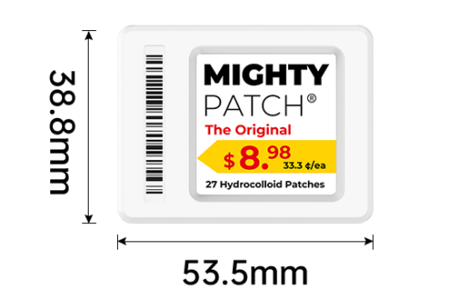

Specifications

Product Dimensions (mm*mm*mm) | 53.5*38.8*15
Active Display Area (mm*mm) | 26.9x26.9
Weight (g) | 22
Case Color | white
Display Size (inch) | 1.54
Resolution (pixel) | 200*200
DPI | 183
Display color | BW, BWR, BWRY
NFC | 1. Complies with ISO/IEC 14443 Type A standard  2. Supports NFC NDEF data format with 200 bytes writable memory  3. Communication distance is reachable maximum 10 mm
LED Flash | Red, Blue, Green, Yellow, White, Cyan, Purple
Working life | 5-10 years (2-4 updates per day)
Battery Spec | 2*375mAh CR2450
Changeable Battery | Battery Pack (replaceable)
Working Temperature (˚C) | 0~40
Working Humidity (%RH) | 30~70
Protection Level | IP54
Certiﬁcation | ROHS,CE,FCC
RF Wireless Communicaiton Parameters | Working Frequency：  2402MHz ~ 2480MHz | System Throughput：  Up to 18,000 labels per hour

MOQ: 5000
Lite Series 2.13”

Model: AES-0213/L 4 color is available

Label with simple design. Perfect in every type of department.

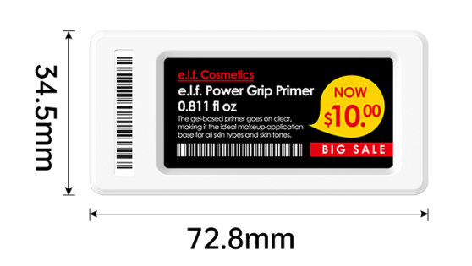

Specifications

Product Dimensions (mm*mm*mm) | 72.8*34.5*13
Active Display Area (mm*mm) | 48x23.1
Weight (g) | 33
Case Color | white
Display Size (inch) | 2.13
Resolution (pixel) | 250*122
DPI | 183
Display color | BW, BWR, BWRY
NFC | 1. Complies with ISO/IEC 14443 Type A standard  2. Supports NFC NDEF data format with 200 bytes writable memory  3. Communication distance is reachable maximum 10 mm
LED Flash | Red, Blue, Green, Yellow, White, Cyan, Purple
Working life | 5-10 years (2-4 updates per day)
Battery Spec | 2*600mAh CR2450
Changeable Battery | Battery Pack (replaceable)
Working Temperature (˚C) | 0~40
Working Humidity (%RH) | 30~70
Protection Level | IP54
Certiﬁcation | ROHS,CE,FCC
RF Wireless Communicaiton Parameters | Working Frequency：  2402MHz ~ 2480MHz | System Throughput：  Up to 18,000 labels per hour
MOQ: 5000
Lite Series 2.66”

Model: AES-0266/L 4 color is available

Label with simple design. Perfect in every type of department.

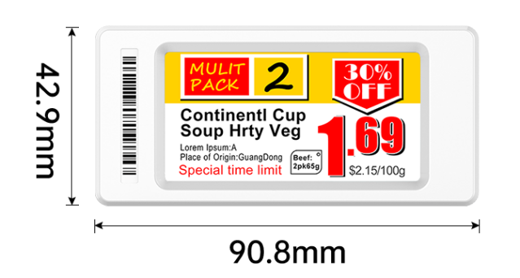

Specifications

Product Dimensions (mm*mm*mm) | 90.8×42.9*13
Active Display Area (mm*mm) | 59.5x30
Weight (g) | 36
Case Color | white
Display Size (inch) | 2.66
Resolution (pixel) | 296*152
DPI | 183
Display color | BW, BWR, BWRY
NFC | 1. Complies with ISO/IEC 14443 Type A standard  2. Supports NFC NDEF data format with 200 bytes writable memory  3. Communication distance is reachable maximum 10 mm
LED Flash | Red, Blue, Green, Yellow, White, Cyan, Purple
Working life | 5-10 years (2-4 updates per day)
Battery Spec | 2*600mAh CR2450
Changeable Battery | Battery Pack (replaceable)
Working Temperature (˚C) | 0~40
Working Humidity (%RH) | 30~70
Protection Level | IP54
Certiﬁcation | ROHS,CE,FCC
RF Wireless Communicaiton Parameters | Working Frequency：  2402MHz ~ 2480MHz | System Throughput：  Up to 15,000 labels per hour

MOQ: 5000
Lite Series 2.9”

Model: AES-0290/L 4 color is available

Label with simple design. Perfect in every type of department.

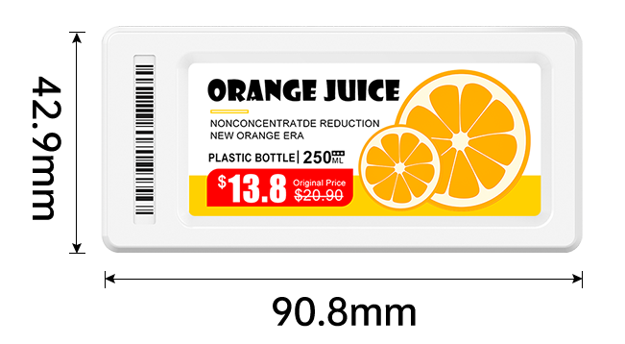

Specifications

Product Dimensions (mm*mm*mm) | 90.8×42.9*13
Active Display Area (mm*mm) | 66x28.5
Weight (g) | 39
Case Color | white
Display Size (inch) | 2.9
Resolution (pixel) | 296*128
DPI | 183
Display color | BW, BWR, BWRY
NFC | 1. Complies with ISO/IEC 14443 Type A standard  2. Supports NFC NDEF data format with 200 bytes writable memory  3. Communication distance is reachable maximum 10 mm
LED Flash | Red, Blue, Green, Yellow, White, Cyan, Purple
Working life | 5-10 years (2-4 updates per day)
Battery Spec | 2*600mAh CR2450
Changeable Battery | Battery Pack (replaceable)
Working Temperature (˚C) | 0~40
Working Humidity (%RH) | 30~70
Protection Level | IP54
Certiﬁcation | ROHS,CE,FCC
RF Wireless Communicaiton Parameters | Working Frequency：  2402MHz ~ 2480MHz | System Throughput：  Up to 15,000 labels per hour

MOQ: 5000
Lite Series 4.2”

Model: AES-0420/L

Perfect for promotion stand, fruit & vegetables and appliances section.

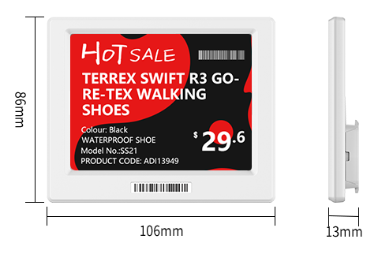

Specifications

Product Dimensions (mm*mm*mm) | 106*86*14.1
Active Display Area (mm*mm) | 84x63
Weight (g) | 83
Case Color | white
Display Size (inch) | 4.2
Resolution (pixel) | 400*300
DPI | 183
Display color | BW, BWR, BWRY
NFC | 1. Complies with ISO/IEC 14443 Type A standard  2. Supports NFC NDEF data format with 200 bytes writable memory  3. Communication distance is reachable maximum 10 mm
LED Flash | Red, Blue, Green, Yellow, White, Cyan, Purple
Working life | 5-10 years (2-4 updates per day)
Battery Spec | 3*600mAh CR2450
Changeable Battery | Battery Pack (replaceable)
Working Temperature (˚C) | 0~40
Working Humidity (%RH) | 30~70
Protection Level | IP54
Certiﬁcation | ROHS,CE,FCC
RF Wireless Communicaiton Parameters | Working Frequency：  2402MHz ~ 2480MHz | System Throughput：  Up to 9,000 labels per hour

MOQ: 2000
Lite Series 7.5”

Model: AES-0750/L

Perfect for promotion stand, fruit & vegetables and appliances section.

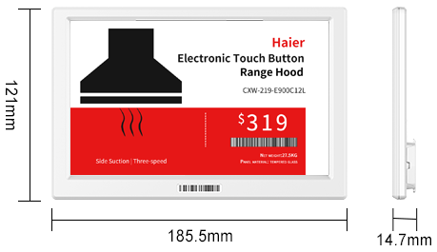

Specifications

Product Dimensions (mm*mm*mm) | 185*121*14
Active Display Area (mm*mm) | 162.6x97.3
Weight (g) | 201
Case Color | white
Display Size (inch) | 7.5
Resolution (pixel) | 800*480
DPI | 183
Display color | BW, BWR, BWRY
NFC | 1. Complies with ISO/IEC 14443 Type A standard  2. Supports NFC NDEF data format with 200 bytes writable memory  3. Communication distance is reachable maximum 10 mm
LED Flash | Red, Blue, Green, Yellow, White, Cyan, Purple
Working life | 5-10 years (2-4 updates per day)
Battery Spec | 4*600mAh CR2450
Changeable Battery | Battery Pack (replaceable)
Working Temperature (˚C) | 0~40
Working Humidity (%RH) | 30~70
Protection Level | IP54
Certiﬁcation | ROHS,CE,FCC
RF Wireless Communicaiton Parameters | Working Frequency：  2402MHz ~ 2480MHz | System Throughput：  Up to 6,000 labels per hour

MOQ: 5000
Slim Series 2.13”

Model: AES-0213/S 4 color is available

Slim design with protective cover. Perfect in every type of department.

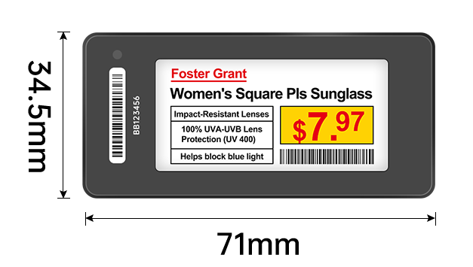

Specifications

Product Dimensions (mm*mm*mm) | 71*34.5*11.2
Active Display Area (mm*mm) | 48x23.1
Weight (g) | 32
Case Color | White, black
Display Size (inch) | 2.13
Resolution (pixel) | 250*122
DPI | 183
Display color | BW, BWR, BWRY
NFC | 1. Complies with ISO/IEC 14443 Type A standard  2. Supports NFC NDEF data format with 200 bytes writable memory  3. Communication distance is reachable maximum 10 mm
LED Flash | Red, Blue, Green, Yellow, White, Cyan, Purple
Working life | 5-10 years (2-4 updates per day)
Battery Spec | 2*600mAh CR2450
Changeable Battery | Battery Pack (replaceable)
Working Temperature (˚C) | 0~40
Working Humidity (%RH) | 30~70
Protection Level | IP54
Certiﬁcation | ROHS,CE,FCC
RF Wireless Communicaiton Parameters | Working Frequency：  2402MHz ~ 2480MHz | System Throughput：  Up to 18,000 labels per hour

MOQ: 5000
Slim Series 2.66”

Model: AES-0266/S 4 color is available

Slim design with protective cover. Perfect in every type of department.

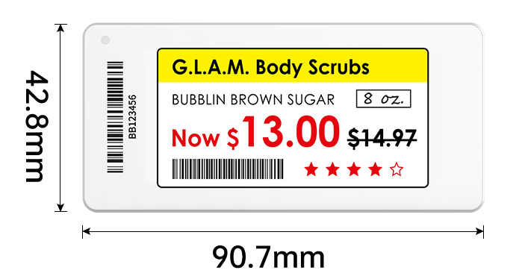

Specifications

Product Dimensions (mm*mm*mm) | 90.7×42.8*11.2
Active Display Area (mm*mm) | 59.5x30
Weight (g) | 38
Case Color | White
Display Size (inch) | 2.66
Resolution (pixel) | 296*152
DPI | 183
Display color | BW, BWR, BWRY
NFC | 1. Complies with ISO/IEC 14443 Type A standard  2. Supports NFC NDEF data format with 200 bytes writable memory  3. Communication distance is reachable maximum 10 mm
LED Flash | Red, Blue, Green, Yellow, White, Cyan, Purple
Working life | 5-10 years (2-4 updates per day)
Battery Spec | 2*600mAh CR2450
Changeable Battery | Battery Pack (replaceable)
Working Temperature (˚C) | 0~40
Working Humidity (%RH) | 30~70
Protection Level | IP54
Certiﬁcation | ROHS,CE,FCC
RF Wireless Communicaiton Parameters | Working Frequency：  2402MHz ~ 2480MHz | System Throughput：  Up to 15,000 labels per hour

MOQ: 5000
Slim Series 2.9”

Model: AES-0290/S 4 color is available

Slim design with protective cover. Perfect in every type of department.

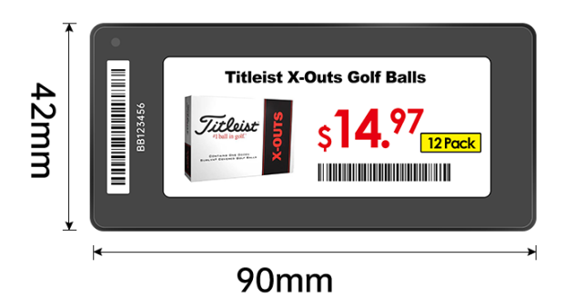

Specifications

Product Dimensions (mm*mm*mm) | 90*42*11.2
Active Display Area (mm*mm) | 66x28.5
Weight (g) | 39
Case Color | White, black
Display Size (inch) | 2.9
Resolution (pixel) | 296*128
DPI | 183
Display color | BW, BWR, BWRY
NFC | 1. Complies with ISO/IEC 14443 Type A standard  2. Supports NFC NDEF data format with 200 bytes writable memory  3. Communication distance is reachable maximum 10 mm
LED Flash | Red, Blue, Green, Yellow, White, Cyan, Purple
Working life | 5-10 years (2-4 updates per day)
Battery Spec | 2*600mAh CR2450
Changeable Battery | Battery Pack (replaceable)
Working Temperature (˚C) | 0~40
Working Humidity (%RH) | 30~70
Protection Level | IP54
Certiﬁcation | ROHS,CE,FCC
RF Wireless Communicaiton Parameters | Working Frequency：  2402MHz ~ 2480MHz | System Throughput：  Up to 15,000 labels per hour

MOQ: 5000
Slim Series 4.2”

Model: AES-0420/S

Perfect for promotion stand, fruit & vegetables and appliances section.

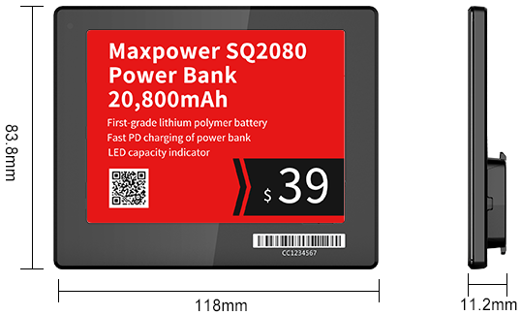

Specifications

Product Dimensions (mm*mm*mm) | 118*83.8*11.2
Active Display Area (mm*mm) | 84x63
Weight (g) | 83
Case Color | White, black
Display Size (inch) | 4.2
Resolution (pixel) | 400*300
DPI | 183
Display color | BW, BWR, BWRY
NFC | 1. Complies with ISO/IEC 14443 Type A standard  2. Supports NFC NDEF data format with 200 bytes writable memory  3. Communication distance is reachable maximum 10 mm
LED Flash | Red, Blue, Green, Yellow, White, Cyan, Purple
Working life | 5-10 years (2-4 updates per day)
Battery Spec | 3*600mAh CR2450
Changeable Battery | Battery Pack (replaceable)
Working Temperature (˚C) | 0~40
Working Humidity (%RH) | 30~70
Protection Level | IP54
Certiﬁcation | ROHS,CE,FCC
RF Wireless Communicaiton Parameters | Working Frequency：  2402MHz ~ 2480MHz | System Throughput：  Up to 9,000 labels per hour

MOQ: 5000
Slim Series 7.5”

Model: AES-0750/S

Perfect for promotion stand, fruit & vegetables and appliances section.

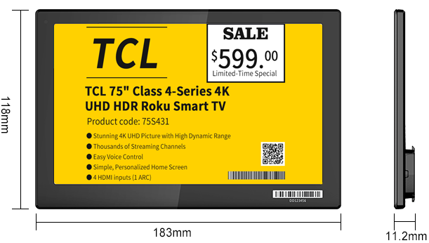

Specifications

Product Dimensions (mm*mm*mm) | 183*118*11.2
Active Display Area (mm*mm) | 162.6x97.3
Weight (g) | 201
Case Color | white
Display Size (inch) | 7.5
Resolution (pixel) | 800*480
DPI | 183
Display color | BW, BWR, BWRY
NFC | 1. Complies with ISO/IEC 14443 Type A standard  2. Supports NFC NDEF data format with 200 bytes writable memory  3. Communication distance is reachable maximum 10 mm
LED Flash | Red, Blue, Green, Yellow, White, Cyan, Purple
Working life | 5-10 years (2-4 updates per day)
Battery Spec | 4*600mAh CR2450
Changeable Battery | Battery Pack (replaceable)
Working Temperature (˚C) | 0~40
Working Humidity (%RH) | 30~70
Protection Level | IP54
Certiﬁcation | ROHS,CE,FCC
RF Wireless Communicaiton Parameters | Working Frequency：  2402MHz ~ 2480MHz | System Throughput：  Up to 6,000 labels per hour

Freezer Series 2.66”

Model: AES-0266/F

Perfect to be used in freezers.

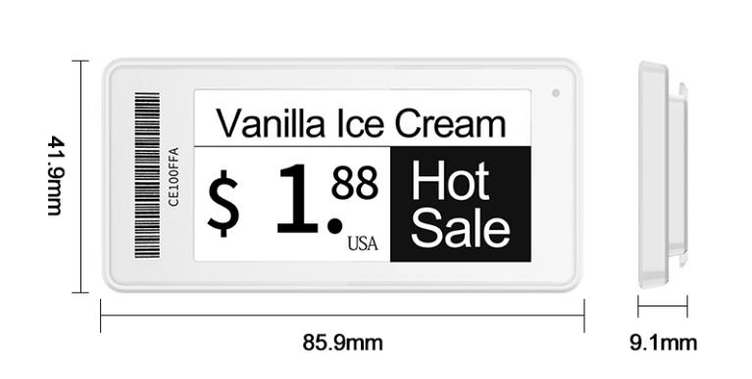

Specifications

Product Dimensions (mm*mm*mm) | 85.9*41.9*9.1
Active Display Area (mm*mm) | 59.5x30
Weight (g) | 32
Case Color | White
Display Size (inch) | 2.66
Resolution (pixel) | 296*152
DPI | 183
Display color | Black and white
NFC | 1. Complies with ISO/IEC 14443 Type A standard  2. Supports NFC NDEF data format with 200 bytes writable memory  3. Communication distance is reachable maximum 10 mm
LED Flash | Red, Blue, Green, Yellow, White, Cyan, Purple
Working life | 5-10 years (2-4 updates per day)
Battery Spec | 1200mAh Polymer battery
Changeable Battery | Not Changeable
Working Temperature (˚C) | -20 C°to + 40 C°
Working Humidity (%RH) | 30~70
Protection Level | IP67
Certiﬁcation | ROHS,CE,FCC
RF Wireless Communicaiton Parameters | Working Frequency：  2402MHz ~ 2480MHz | System Throughput：  Up to 15,000 labels per hour
MOQ: 2000
Rock Series 2.13”

Model: AES-0213/R

Slim design with protective cover. Perfect in every type of department.

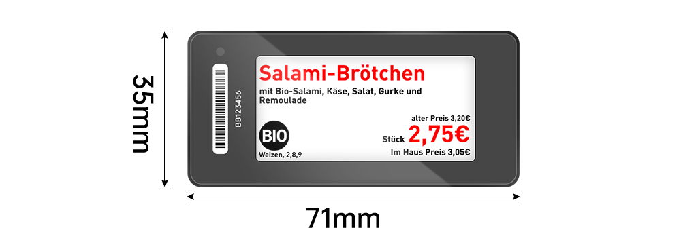

Specifications

Product Dimensions (mm*mm*mm) | 71*34.5*11.2
Active Display Area (mm*mm) | 48x23.1
Weight (g) | 32
Case Color | White, black
Display Size (inch) | 2.13
Resolution (pixel) | 250*122
DPI | 183
Display color | BW, BWR, BWRY
NFC | 1. Complies with ISO/IEC 14443 Type A standard  2. Supports NFC NDEF data format with 200 bytes writable memory  3. Communication distance is reachable maximum 10 mm
LED Flash | Red, Blue, Green, Yellow, White, Cyan, Purple
Working life | 5-10 years (2-4 updates per day)
Battery Spec | 2*600mAh CR2450
Changeable Battery | Universal single button battery (replaceable)
Working Temperature (˚C) | 0~40
Working Humidity (%RH) | 30~70
Protection Level | IP54
Certiﬁcation | ROHS,CE,FCC
RF Wireless Communicaiton Parameters | Working Frequency：  2402MHz ~ 2480MHz | System Throughput：  Up to 18,000 labels per hour

MOQ: 2000
Rock Series 2.9”

Model: AES-0290/R

Slim design with protective cover. Perfect in every type of department.

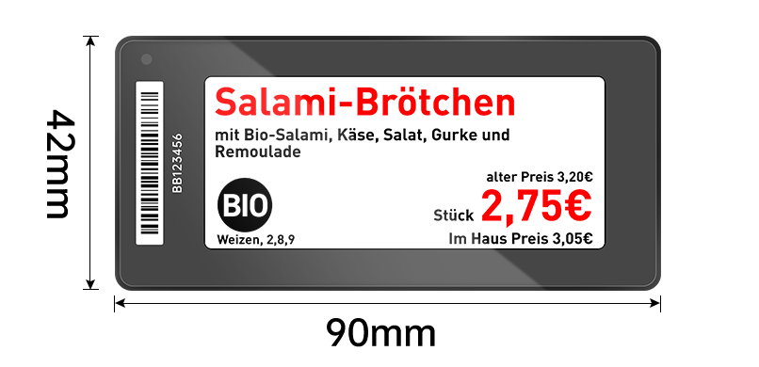

Specifications

Product Dimensions (mm*mm*mm) | 90*42*11.2
Active Display Area (mm*mm) | 66x28.5
Weight (g) | 39
Case Color | White, black
Display Size (inch) | 2.9
Resolution (pixel) | 296*128
DPI | 183
Display color | BW, BWR, BWRY
NFC | 1. Complies with ISO/IEC 14443 Type A standard  2. Supports NFC NDEF data format with 200 bytes writable memory  3. Communication distance is reachable maximum 10 mm
LED Flash | Red, Blue, Green, Yellow, White, Cyan, Purple
Working life | 5-10 years (2-4 updates per day)
Battery Spec | 2*600mAh CR2450
Changeable Battery | Universal single button battery (replaceable)
Working Temperature (˚C) | 0~40
Working Humidity (%RH) | 30~70
Protection Level | IP54
Certiﬁcation | ROHS,CE,FCC
RF Wireless Communicaiton Parameters | Working Frequency：  2402MHz ~ 2480MHz | System Throughput：  Up to 15,000 labels per hour

MOQ: 2000
Rock Series 3.5”

Model: AES-0350/R 4 color is available

Slim design with protective cover. Perfect in every type of department.

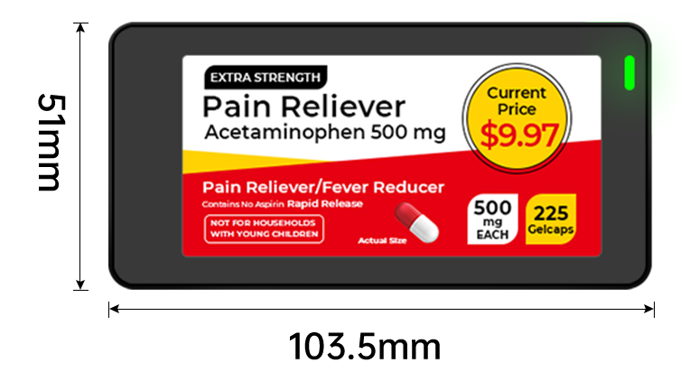

Specifications

Product Dimensions (mm*mm*mm) | 103.5×51×12.9
Active Display Area (mm*mm) | 79x38
Weight (g) | 68
Case Color | White, black
Display Size (inch) | 3.5
Resolution (pixel) | 384*184
DPI | 183
Display color | BW, BWR, BWRY
NFC | 1. Complies with ISO/IEC 14443 Type A standard  2. Supports NFC NDEF data format with 200 bytes writable memory  3. Communication distance is reachable maximum 10 mm
LED Flash | Red, Blue, Green, Yellow, White, Cyan, Purple
Working life | 5-10 years (2-4 updates per day)
Battery Spec | 2*600mAh CR2450
Changeable Battery | Universal single button battery (replaceable)
Working Temperature (˚C) | 0~40
Working Humidity (%RH) | 30~70
Protection Level | IP54
Certiﬁcation | ROHS,CE,FCC
RF Wireless Communicaiton Parameters | Working Frequency：  2402MHz ~ 2480MHz | System Throughput：  Up to 12,000 labels per hour
MOQ: 2000
Rock Series 4.2”

Model: AES-0420/R

Perfect for promotion stand, fruit & vegetables and appliances section.

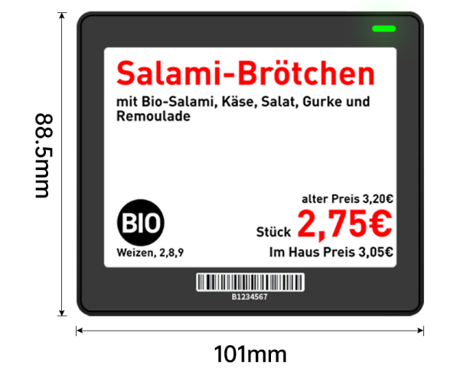

Specifications

Product Dimensions (mm*mm*mm) | 101*88.5*12.9
Active Display Area (mm*mm) | 84x63
Weight (g) | 83
Case Color | White, black
Display Size (inch) | 4.2
Resolution (pixel) | 400*300
DPI | 183
Display color | BW, BWR, BWRY
NFC | 1. Complies with ISO/IEC 14443 Type A standard  2. Supports NFC NDEF data format with 200 bytes writable memory  3. Communication distance is reachable maximum 10 mm
LED Flash | Red, Blue, Green, Yellow, White, Cyan, Purple
Working life | 5-10 years (2-4 updates per day)
Battery Spec | 4*600mAh CR2450
Changeable Battery | Universal single button battery (replaceable)
Working Temperature (˚C) | 0~40
Working Humidity (%RH) | 30~70
Protection Level | IP54
Certiﬁcation | ROHS,CE,FCC
RF Wireless Communicaiton Parameters | Working Frequency：  2402MHz ~ 2480MHz | System Throughput：  Up to 9,000 labels per hour

MOQ: 2000
Rock Series 5.83”

Model: AES-0583/R

Perfect for promotion stand, fruit & vegetables and appliances section.

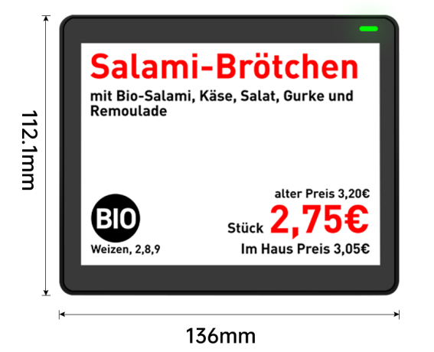

Specifications

Product Dimensions (mm*mm*mm) | 136*112*12.9
Active Display Area (mm*mm) | 119x88
Weight (g) | 105
Case Color | White, black
Display Size (inch) | 5.83
Resolution (pixel) | 648*480
DPI | 183
Display color | BW, BWR, BWRY
NFC | 1. Complies with ISO/IEC 14443 Type A standard  2. Supports NFC NDEF data format with 200 bytes writable memory  3. Communication distance is reachable maximum 10 mm
LED Flash | Red, Blue, Green, Yellow, White, Cyan, Purple
Working life | 5-10 years (2-4 updates per day)
Battery Spec | 4*600mAh CR2450
Changeable Battery | Universal single button battery (replaceable)
Working Temperature (˚C) | 0~40
Working Humidity (%RH) | 30~70
Protection Level | IP54
Certiﬁcation | ROHS,CE,FCC
RF Wireless Communicaiton Parameters | Working Frequency：  2402MHz ~ 2480MHz | System Throughput：  Up to 9,000 labels per hour
MOQ: 2000
Rock Series 10.2”

Model: AES-0102/R

Perfect for promotion stand, fruit & vegetables and appliances section.

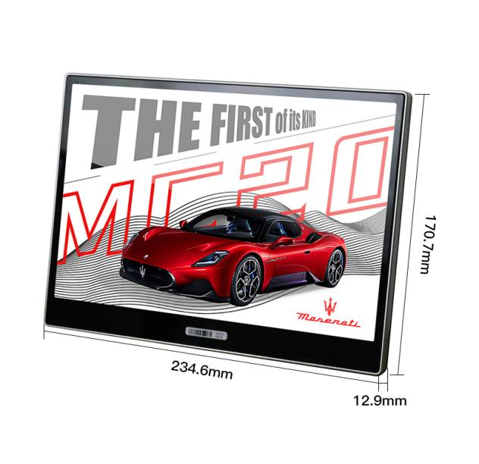

Specifications

Product Dimensions (mm*mm*mm) | 234.6×170.7×12.9
Active Display Area (mm*mm) | 215.52*143.86
Weight (g) | 220
Case Color | White, black
Display Size (inch) | 10.2
Resolution (pixel) | 960*640
DPI | 183
Display color | BW, BWR, BWRY
NFC | None
LED Flash | None
Working life | 5-10 years (2-4 updates per day)
Battery Spec | 8*600mAh CR2450
Changeable Battery | Universal single button battery (replaceable)
Working Temperature (˚C) | 0~40
Working Humidity (%RH) | 30~70
Protection Level | IP54
Certiﬁcation | ROHS,CE,FCC
RF Wireless Communicaiton Parameters | Working Frequency：  2402MHz ~ 2480MHz | System Throughput：  Up to 6,000 labels per hour

7 color ESL 7.3”

Model: AES-0730/SC

Perfect for promotion stand, fruit & vegetables and appliances section.

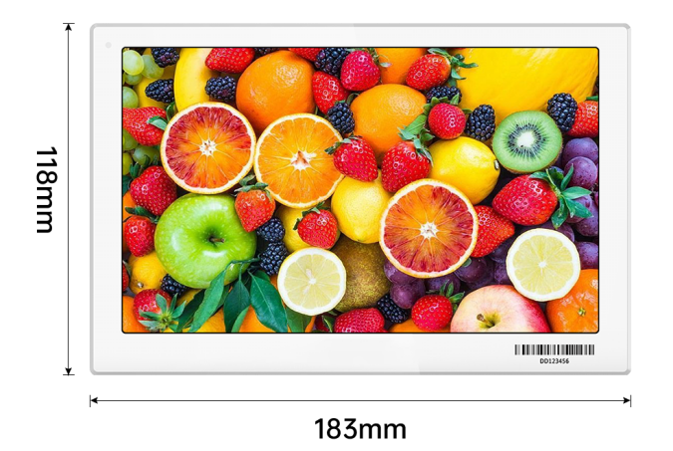

Specifications

Product Dimensions (mm*mm*mm) | 183*118*11.2
Active Display Area (mm*mm) | 160x96
Weight (g) | 201
Case Color | white
Display Size (inch) | 7.3
Resolution (pixel) | 800*480
DPI | 183
Display color | Black, White, Red, Yellow, Blue, Green, Orange
NFC | 1. Complies with ISO/IEC 14443 Type A standard  2. Supports NFC NDEF data format with 200 bytes writable memory  3. Communication distance is reachable maximum 10 mm
LED Flash | Red, Blue, Green, Yellow, White, Cyan, Purple
Working life | 5-10 years (2-4 updates per day)
Battery Spec | 4*600mAh CR2450
Changeable Battery | Battery Pack (replaceable)
Working Temperature (˚C) | 0~40
Working Humidity (%RH) | 30~70
Protection Level | IP54
Certiﬁcation | ROHS,CE,FCC
RF Wireless Communicaiton Parameters | Working Frequency：  2402MHz ~ 2480MHz | System Throughput：  Up to 6,000 labels per hour

ESL Gateway
Model: AES-B001
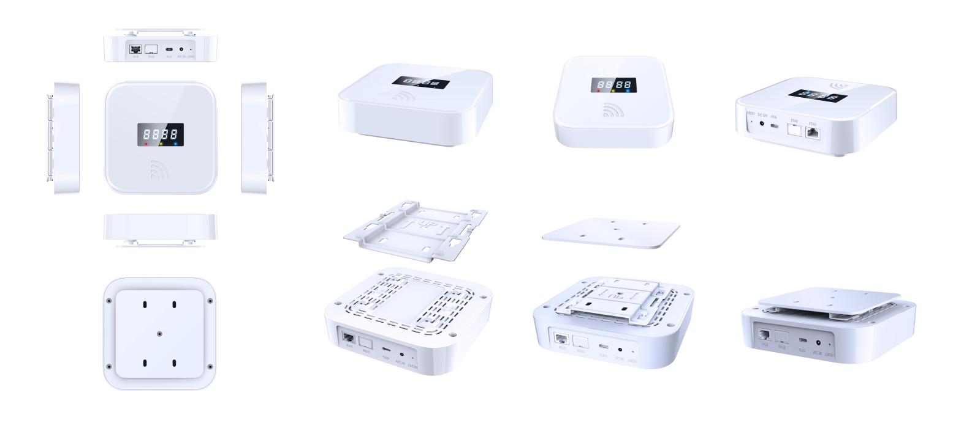
The AES-B001 Electronic Shelf Label Control Base Station provides network access, tag communication, and update control for ESL systems. It integrates Wi-Fi, RJ45, Bluetooth, and multi-channel RF communication, supports desktop, vertical, ceiling-mounted, and other installation methods, and is suitable for retail stores, supermarket chains, warehouses, and centralized ESL management scenarios.
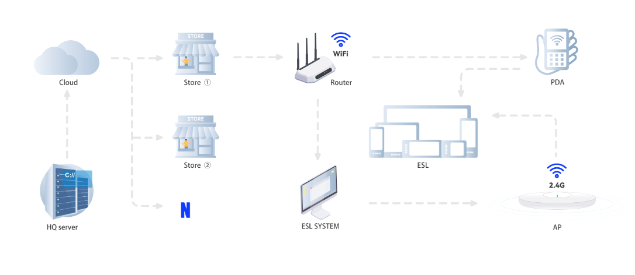
Features
Private communication protocol to ensure communication security and reduce interference;
High-speed bi-directional communication with ESL labels;
Supports Wi-Fi, RJ45 Ethernet, Bluetooth, and multi-channel RF communication;
Supports PoE, 12 V DC, and USB Type-C 5 V power input;
Compatible with PanPanTech ESL labels;
LED indicators display real-time operating status.
Hardware configuration
AES-B001 specifications
Product Dimension(mm) | 155 x 155 x 35 (L x W x T)
Weight | approx. 332 g
Housing Color | White
Housing Material | ABS + PC
Mounting | Desktop, vertical, ceiling-mounted, and other installation methods
Main processor module | Quad-core ARM Cortex-A35 CPU, 1 GB DDR3 RAM, 16 GB eMMC storage
Display | 4-digit LED segment display
Indicator LEDs | Red: power; Yellow: operating status; Green: special status
Power supply module | 12 V DC 1 A / USB Type-C 5 V 2 A / PoE 48 V, max. 30 W
Network module | Wi-Fi 2.4 GHz AP/Station; RJ45 Ethernet; BLE 5.2 private protocol
RF module | Four-channel RF module, two transmit channels and two receive channels
Working Frequency | 2.4 GHz (2400 MHz - 2500 MHz), private protocol
Communication Distance | 0-25 m in non-open environments
Operating Current | <350 mA
Operating Temperature | 0 °C ~ 50 °C
Storage Temperature | -10 °C ~ 50 °C
Software Support | ESL management system / base-station control system; USB Type-C debugging

